Experiment 1

Aim: Creation of matrices and performing arithmetic operations on them.

Software used: Octave/Octave online (<https://octave-online.net>)

Procedure:

|  |
| --- |
| %CREATION OF MATRIX  A = [1 2 3] %Row Vector  B = [1;2;3] %Column Vector  C = [1 2 3;4,6,6;7,8,9]  D = [0,0,0;4,5,6;7,8,9]  E = [1,2,4,5,3;1,2,4,5,6;5,6,4,3,3;1,2,4,5,5]  %ADDITION  F = C + D  G = plus(C,D)  %SUBTRACTION  H = C - D  I = minus(C,D)  %MULTIPLICATION  H = A * B  s = mtimes(A,B)  %ELEMENT WISE MULTIPLICATION (Hadamard Product)  I = C .* D  J = times(C,D)  %DIVISION  K = [2 4 6 8; 3 5 7 9]  L = [10,10,10,10;10,10,10,10]  M = K./L  N = rdivide(K,L)  O = ldivide(L,K)  %EXPONENTIAL  p = [1 1 0; 0 0 2; 0 0 -1]  q = exp(p)  r = expm(p)  %Transpose of matrix  s = C.'  t = transpose(C)  %DETERMINANT OF matrix  u = det(C)  %Inverse of matrix  v = C^(-1)  w = inv(C)  x = v*C  y = w*C  %Rank of matrix  z = rank(C)  %ones  zz = 10 * ones(2,3)  zzz = zeros(2,4) |

Output:

|  |
| --- |
| A =  1 2 3  B =  1  2  3  C =  1 2 3  4 6 6  7 8 9  D =  0 0 0  4 5 6  7 8 9  E =  1 2 4 5 3  1 2 4 5 6  5 6 4 3 3  1 2 4 5 5  F =  1 2 3  8 11 12  14 16 18  G =  1 2 3  8 11 12  14 16 18  H =  1 2 3  0 1 0  0 0 0  I =  1 2 3  0 1 0  0 0 0  H = 14  s = 14  I =  0 0 0  16 30 36  49 64 81  J =  0 0 0  16 30 36  49 64 81  K =  2 4 6 8  3 5 7 9  L =  10 10 10 10  10 10 10 10  M =  0.2000 0.4000 0.6000 0.8000  0.3000 0.5000 0.7000 0.9000  N =  0.2000 0.4000 0.6000 0.8000  0.3000 0.5000 0.7000 0.9000  O =  0.2000 0.4000 0.6000 0.8000  0.3000 0.5000 0.7000 0.9000  p =  1 1 0  0 0 2  0 0 -1  q =  2.7183 2.7183 1.0000  1.0000 1.0000 7.3891  1.0000 1.0000 0.3679  r =  2.7183 1.7183 1.0862  0 1.0000 1.2642  0 0 0.3679  s =  1 4 7  2 6 8  3 6 9  t =  1 4 7  2 6 8  3 6 9  u = -12.000  v =  -0.5000 -0.5000 0.5000  -0.5000 1.0000 -0.5000  0.8333 -0.5000 0.1667  w =  -0.5000 -0.5000 0.5000  -0.5000 1.0000 -0.5000  0.8333 -0.5000 0.1667  x =  1.0000 0 0.0000  0.0000 1.0000 -0.0000  0.0000 0.0000 1.0000  y =  1.0000 0 0.0000  0.0000 1.0000 -0.0000  0.0000 0.0000 1.0000  z = 3  zz =  10 10 10  10 10 10  zzz =  0 0 0 0  0 0 0 0 |

Discussion:

The vectors in this experiment - row vector, column vector and matrices are created using the shorthand method, all arithmetic operations are performed using both the predefined functions that octave provisions along with using operator notation as well. Matrix operations such as determinant, transpose etc. are also performed with both predefined functions and element wise operations.

Result:

The vectors and matrices were created and output for both the methods – predefined functions and element wise operations is same.

Conclusion:

Experiment 2

Aim: Commands for matrix manipulation.

Software used: Octave/Octave online (<https://octave-online.net>)

Procedure:

|  |
| --- |
| %CONCATENATE  A = [1 2 3 4;5 6 7 8]  B = [3 5 2 1;7 4 9 8]  C = [A B]  D = [A;B]  CC = cat (2,A,B)  DD = cat (1,A,B)  %INDEXING  E = A([1:2],[2:4])  EE = A(6)  %SORTING BY COLUMNWISE  F = sort(B)  G = sort(B,'descend')  %SORTING BY ROW WISE  H = sort(B,2)  I = sort(B,2,'descend')  %SHIFTING  J = circshift([1 2 3 4 5 6 7],2)  JJ = circshift([1;2;3;4;5;6;7],2)  %RESHAPING  K = reshape ([1, 2, 3, 4], 2, 2)  L = reshape ([1, 2, 3, 4], 2, [])  M = reshape ([1, 2;3, 4], 1,[])  %FLIPPING  N = flip(A)  O = flip(A,2)  %ROTATION  rot90 ([1, 2; 3, 4], -1)  rot90 ([1, 2; 3, 4], 1)  rot90 ([1, 2; 3, 4], 7)  rotdim ([1, 2; 3, 4], -1)  rotdim ([1, 2; 3, 4], -1, [1, 2])  rotdim ([1, 2; 3, 4], 1, [1, 2])  %CREATING X AND Y MATRICES  x = [2 3 5 6 0 1 9 8]  y = [1 4 7 2 0 6 2 0]  less = x < y  more = x > y  lessequal = x <= y  moreequal = x>= y  equal = x == y  notequal = x ~= y  less2 = lt(x,y)  more2 = gt(x,y)  lessequal2 = le(x,y)  moreequal2 = ge(x,y)  equal2 = eq(x,y)  notequal2 = ne(x,y)  p = [1 2 3 4 NaN]  q = [1 2 3 4 NaN]  equality = isequal(p,q)  noteq = isequaln(p,q)  %LOGICAL OPERATORS  or1 = x | y  or2 = or(x,y)  and1 = x & y  and2 = and(x,y)  notA = not(y)  nta = ~y  exor = xor(x,y) |

Output:

|  |
| --- |
| A =  1 2 3 4  5 6 7 8  B =  3 5 2 1  7 4 9 8  C =  1 2 3 4 3 5 2 1  5 6 7 8 7 4 9 8  D =  1 2 3 4  5 6 7 8  3 5 2 1  7 4 9 8  CC =  1 2 3 4 3 5 2 1  5 6 7 8 7 4 9 8  DD =  1 2 3 4  5 6 7 8  3 5 2 1  7 4 9 8  E =  2 3 4  6 7 8  EE = 7  F =  3 4 2 1  7 5 9 8  G =  7 5 9 8  3 4 2 1  H =  1 2 3 5  4 7 8 9  I =  5 3 2 1  9 8 7 4  J =  6 7 1 2 3 4 5  JJ =  6  7  1  2  3  4  5  K =  1 3  2 4  L =  1 3  2 4  M =  1 3 2 4  N =  5 6 7 8  1 2 3 4  O =  4 3 2 1  8 7 6 5  ans =  3 1  4 2  ans =  2 4  1 3  ans =  3 1  4 2  ans =  3 1  4 2  ans =  3 1  4 2  ans =  2 4  1 3  x =  2 3 5 6 0 1 9 8  y =  1 4 7 2 0 6 2 0  less =  0 1 1 0 0 1 0 0  more =  1 0 0 1 0 0 1 1  lessequal =  0 1 1 0 1 1 0 0  moreequal =  1 0 0 1 1 0 1 1  equal =  0 0 0 0 1 0 0 0  notequal =  1 1 1 1 0 1 1 1  less2 =  0 1 1 0 0 1 0 0  more2 =  1 0 0 1 0 0 1 1  lessequal2 =  0 1 1 0 1 1 0 0  moreequal2 =  1 0 0 1 1 0 1 1  equal2 =  0 0 0 0 1 0 0 0  notequal2 =  1 1 1 1 0 1 1 1  p =  1 2 3 4 NaN  q =  1 2 3 4 NaN  equality = 0  noteq = 1  or1 =  1 1 1 1 0 1 1 1  or2 =  1 1 1 1 0 1 1 1  and1 =  1 1 1 1 0 1 1 0  and2 =  1 1 1 1 0 1 1 0  notA =  0 0 0 0 1 0 0 1  nta =  0 0 0 0 1 0 0 1  exor =  0 0 0 0 0 0 0 1 |

Discussion:

In this experiment matrices are created, and matrix manipulation functions are applied on the same matrices. The functions include rotation using $rot90$, sorting using $sort$, reshaping using $reshape$, flipping the matrices using $flip$. Logical operations are applied simply using the logical operators.

Result:

Outputs for every function mentioned above applied on the defined matrices are projected in the output section.

Conclusion:

Several functions were successfully applied on the matrices.

Experiment 3A

Aim: Vector addition and random plots.

Software used: Octave/Octave online (<https://octave-online.net>)

Procedure:

|  |
| --- |
| A = 1:10 #vector from 1 to 10  AA = 1:0.5:10 #vector from 1 to 10 with step size of 0.5  AAA = 1:0.1:10 #vector from 1 to 10 with step size of 0.1  B = [1 2 3;4 5 6;7 8 9]  #Sum of elements of a VECTOR  saa = sum(AA)  saaa = sum(AAA)  sa = sum(A)  #Sum of elements of MATRIX  sb = sum(B) #sum of elements columnwise  sbc = sum(B,1) #sum of elements columnwise  sbr = sum(B,2) #sum of elements rowwise  #Cumulative sum of elements of a VECTOR  sca = cumsum(A)  #Cumulative sum of elements of a MATRIX  scb = cumsum(B) #cumulative sum of elements columnwise  scbc = cumsum(B,1) #cumulative su  m of elements columnwise  scbr = cumsum(B,2) #cumulative sum of elements rowwise  #Generating random real no.s between 0 and 1  C = rand  D = rand  #Generating matrix with its elements as random real no.s between 0 and 1  E = rand(5,3)  F = rand(5)  #Ploting with the help of plot()  X = 0:0.1:10  Yexp = exp(X)  Ysin = sin(X)  Ycos = cos(X)  pa = plot(10:-1:1)  pexp = plot(X,Yexp)  psin = plot(X,Ysin)  pcos = plot(X,Ycos) |

Output:

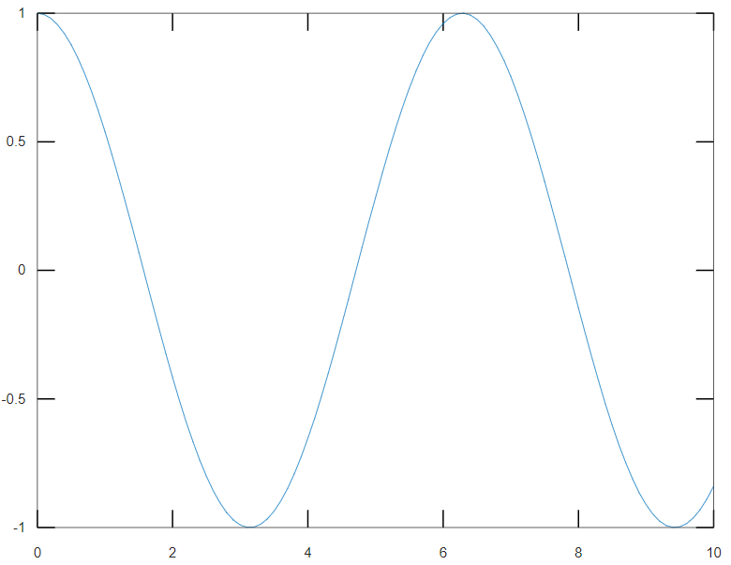

Discussion:

In this experiment vectors are created and their row-wise and column-wise, along with their cumulative sum is calculated with functions $sum$ and $cumsum$ respectively. Vectors and matrices are also created using rand function. Finally, sine, exponential and cosine plots of a vector $X$ are generated using $sin$, $exp$ and $cosine$ functions respectively.

Result:

Sum and cumulative sum of matrices, and plots of vectors were plotted successfully.

Conclusion:

Experiment 3B

Aim:

Software used: Octave/Octave online (<https://octave-online.net>)

Procedure:

|  |
| --- |
| A = 1:10  sum = 0  for i=1 : length(A)  sum = sum + A(i)  end  B = [1 2 3;4 5 6]  for i=1 : length(B([1:end],1))  s = 0  for j=1 : length(B)  s = s + B(i,j)  end  end  disp('')  for i=1 : size(B,1)  s = 0  for j=1 : size(B,2)  s = s + B(i,j)  end  end |

Output:

|  |
| --- |
| A =  1 2 3 4 5 6 7 8 9 10  sum = 0  sum = 1  sum = 3  sum = 6  sum = 10  sum = 15  sum = 21  sum = 28  sum = 36  sum = 45  sum = 55  B =  1 2 3  4 5 6  s = 0  s = 1  s = 3  s = 6  s = 0  s = 4  s = 9  s = 15  s = 0  s = 1  s = 3  s = 6  s = 0  s = 4  s = 9  s = 15 |

Discussion:

This experiment constitutes calculating the sum of a vector A using a for loop rather than the predefined function Octave provisions, for a deeper understanding of indexing. It also encompasses calculation of row-wise sum of a matrix B.

Result:

The sum of vector A using for loop is the same as of the output of $sum$ function, same goes for row-wise sum of matrix B.

Conclusion:

Sum of vector and row-wise sum of matrix were calculated using for loop successfully.

Experiment 4A

Aim:

Software used: Octave/Octave online (<https://octave-online.net>)

Procedure:

|  |
| --- |
| round(99.9987)  ceil(99.9)  ceil(-99.9)  floor(99.9)  floor(-99.9)  fix(50.55)  fix(-50.55)  #Trigonomeetric Functions  t = -pi:0.1:pi  subplot(3,2,1)  plot(t,sin(t))  xlabel('t')  ylabel('sin(t)')  title('Plot of sin(t)')  subplot(3,2,2)  plot(t,cos(t))  xlabel('t')  ylabel('cos(t)')  title('Plot of cos(t)')  subplot(3,2,3)  plot(t,tangent)  xlabel('t')  ylabel('tan(t)')  title('Plot of tan(t)')  t1 = -pi+0.01:0.01:-0.01  t2 = 0.01:0.01:pi-0.01  subplot(3,2,4)  plot(t,csc(t))  xlabel('t')  ylabel('cosec(t)')  title('Plot of cosec(t)')  t1 = -pi/2+0.01:0.01:pi/2-0.01;  t2 = pi/2+0.01:0.01:(3*pi/2)-0.01;  subplot(3,2,5)  plot(t,sec(t))  xlabel('t')  ylabel('sec(t)')  title('Plot of sec(t)')  t1 = -pi+0.01:0.01:-0.01;  t2 = 0.01:0.01:pi-0.01;  subplot(3,2,6)  plot(t,cot(t))  xlabel('t')  ylabel('cot(t)')  title('Plot of cot(t)') |

Output:

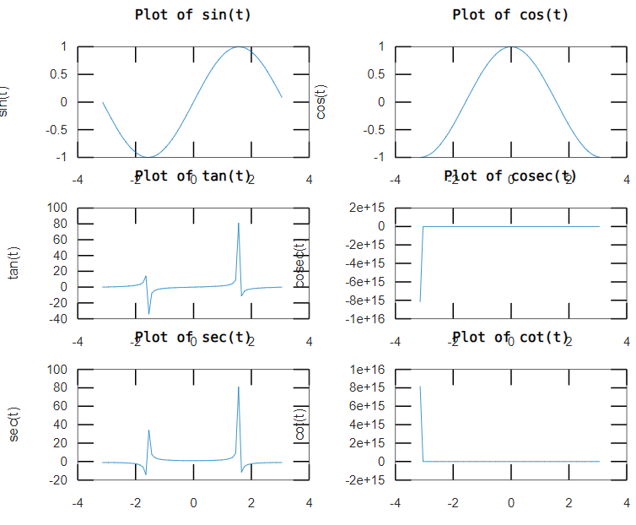

Discussion:

In this experiment all trigonometric functions – sine, cosine, tangent, cosecant, secant and cotangent are plotted using $sin$, $cos$, $tan$, $csc$, $sec$ and $cot$ functions provided by Octave between the range of $-π$ to $π$ with a step size of 0.1.

Result:

Plots of every trigonometric functions in the range of $-π$ to $π$ were generated successfully.

Conclusion:

$sin$, $cos$, $tan$, $csc$, $sec$ and $cot$ functions can be used to generate trigonometric plots provided a vector of values, easily.

Experiment 4B

Aim:

Software used: Octave/Octave online (<https://octave-online.net>)

Procedure:

|  |
| --- |
| x = 1:20  subplot(4,1,1)  plot(x,log(x))  xlabel('Values of x')  ylabel('log(x)')  title('Plot of log(x)')  subplot(4,1,2)  plot(x,log10(x))  xlabel('Values of x')  ylabel('log10(x)')  title('Plot of log10(x)')  subplot(4,1,3)  plot(x,sqrt(x))  xlabel('Values of x')  ylabel('sqrt(x)')  title('Plot of sqrt(x)')  subplot(4,1,4)  plot(x,nthroot(x,5))  xlabel('Values of x')  ylabel('5th root(x)')  title('Plot of 5th root(x)') |

Output:

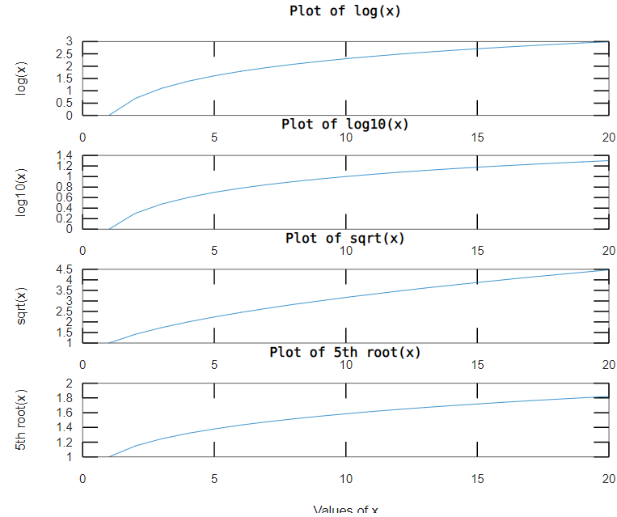

Discussion:

In this experiment, natural logarithm, logarithm to the base 10, square root and nth root of a vector $x$ are calculated using $log$, $log10$, $sqrt$, and $nthroot$ functions provided by Octave. Further plots of these functions are plotted using the $plot$ function.

Result:

Plots of these functions were generated successfully.

Conclusion:

Experiment 5

Aim:

Software used: Octave/Octave online (<https://octave-online.net>)

Procedure:

|  |
| --- |
| for n = 1:100  X(n) = ((-1)^(n+1))/(2*n-1)  end  sumX = sum(X)  t = 0.04:0.04:4  subplot(4,2,1)  plot(t,X)  xlabel('Values of t')  ylabel('X')  title('Plot of X')  subplot(4,2,2)  plot(t,X.^3)  xlabel('Values of t')  ylabel('X^3')  title('Plot of X^3')  subplot(4,2,3)  plot(t,exp(X))  xlabel('Values of t')  ylabel('e^X')  title('Plot of e^X')  subplot(4,2,4)  plot(t,exp(X.^2))  xlabel('Values of t')  ylabel('exp(X^2)')  title('Plot of exp(X^2)') |

Output:

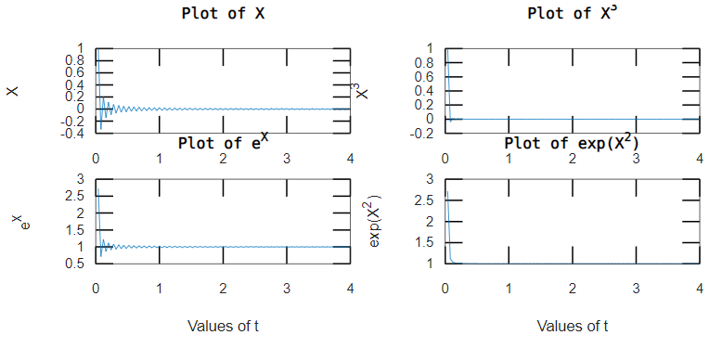

Discussion:

Result:

Conclusion:

Experiment 6

Aim: Frequency curve

Software used: Octave/Octave online (<https://octave-online.net>)

Procedure:

|  |
| --- |
| t = 0:0.05*pi:2*pi  x = sin(t)  plot(t,x,'r-')  xlabel('t')  ylabel('sine(t)')  title('Plot of sin(t)')  legend('sine(t)')  #text(pi,0,'\Leftarrow sin(\pi)','FontSize',18)  hold on  x1 = sin(3*t)  plot(t,x1,'b+-')  xlabel('radians')  ylabel('amplitude')  title('Plot of sin(3{\alpha}) over existig wave sin({\alpha})')  legend('sine(t)','sin(3t)')  text(pi,0,'\Leftarrow sin(3({\alpha}))','FontSize',18)  x2 = sin(4*t)  plot(t,x2,'g*-')  xlabel('t')  ylabel('sine(t)')  title('Plot of sin(t)')  legend('sine(t)','sin(3t)','sin(4t)')  #text(pi,0,'\Leftarrow sin(\pi)','FontSize',18)  hold off |

Output:

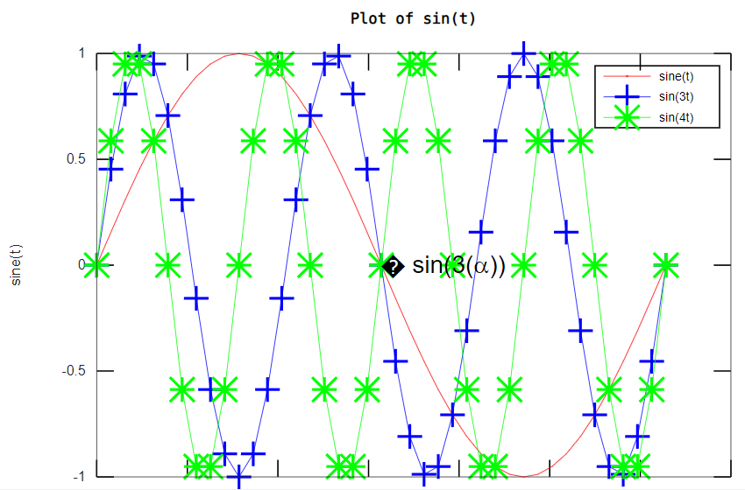

Discussion:

Result:

Conclusion:

Experiment 7

Aim: Frequency curve

Software used: Octave/Octave online (<https://octave-online.net>)

Procedure:

|  |
| --- |
| T = input('Enter the value of T: ')  if (T<0)  disp('Enter a value greater then 0')  elseif (0<T) && (T<100)  fprintf('For T = %d, ',T)  H = T-10  elseif (T>100)  fprintf('For T = %d ',T)  H = (0.45*T)+900  endif |

Output:

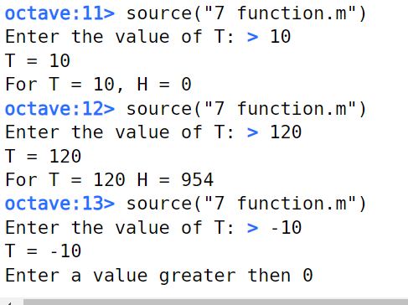

Discussion:

Result:

Conclusion:

Experiment 7

Aim: Frequency curve

Software used: Octave/Octave online (<https://octave-online.net>)

Procedure:

|  |
| --- |
| T = input('Enter the value of T: ')  if (T<0)  disp('Enter a value greater then 0')  elseif (0<T) && (T<100)  fprintf('For T = %d, ',T)  H = T-10  elseif (T>100)  fprintf('For T = %d ',T)  H = (0.45*T)+900  endif |

Output:



Discussion:

Result:

Conclusion:

Experiment 8

Aim: Frequency curve

Software used: Octave/Octave online (<https://octave-online.net>)

Procedure:

|  |
| --- |
| ode1 = @(x,y)(x^3-2*y)/x  [x,y] = ode45(ode1,[1.01:0.01:3],4.2)  plot(x,y,'linewidth',2)  xlabel('x')  ylabel('y')  grid on  title('Solution to ODE, dy/dx = (x^3-2*y)/x') |

Output:

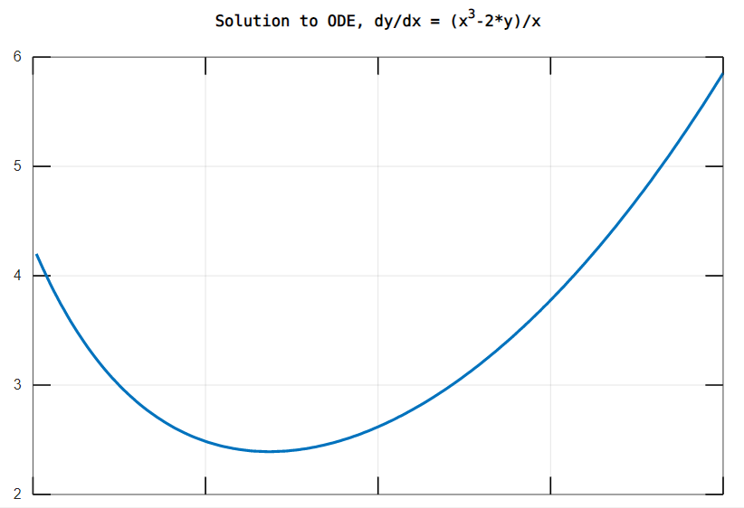

Discussion:

Result:

Conclusion:

Experiment 8

Aim: Frequency curve

Software used: Octave/Octave online (<https://octave-online.net>)

Procedure:

|  |
| --- |
| ode1 = @(x,y)(x^3-2*y)/x  [x,y] = ode45(ode1,[1.01:0.01:3],4.2)  plot(x,y,'linewidth',2)  xlabel('x')  ylabel('y')  grid on  title('Solution to ODE, dy/dx = (x^3-2*y)/x') |

Output:



Discussion:

Result:

Conclusion:

Experiment 10

Aim: Frequency curve

Software used:

Octave/Octave online (<https://octave-online.net>)

Matlab online ([https://matlab.mathworks.com](https://matlab.mathworks.comt))

Procedure:

|  |
| --- |
| x = [10 15 20 25];  bar(x); |
| x = [10 15 20 25];  pie(x); |
| pgon = polyshape([0 0 3 1],[1 4 0 1]);  figure  plot(pgon)  [X,Y,Z] = peaks;  contour(X,Y,Z,100) |

Output:

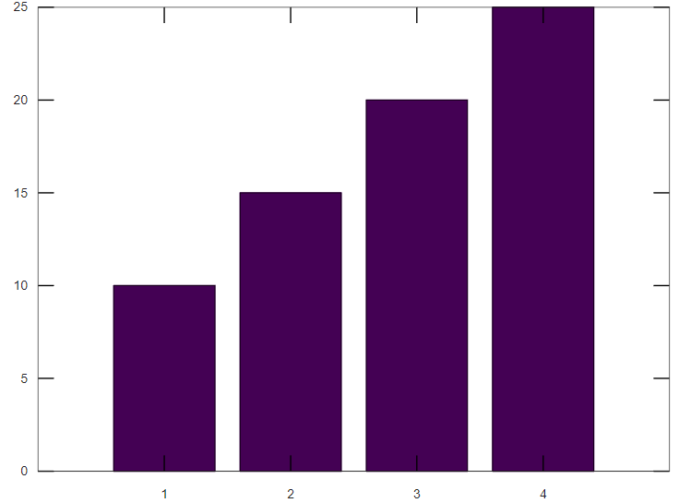

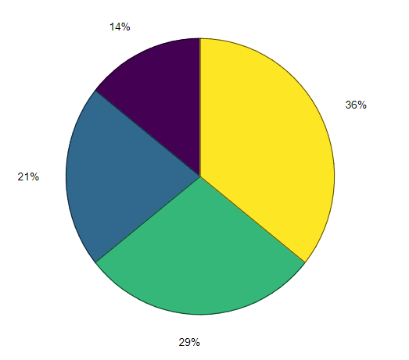

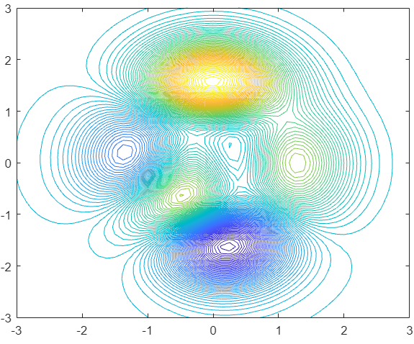

Discussion:

Result:

Conclusion: